I’m going to the museum

[insert photo of museum building]

Before I go to the museum

I’m going to [insert name] museum | [Insert photo of museum building. Change width of all photos to 8cm]
If I am nervous about going I can talk to someone and ask questions first  I can call [insert telephone number] | 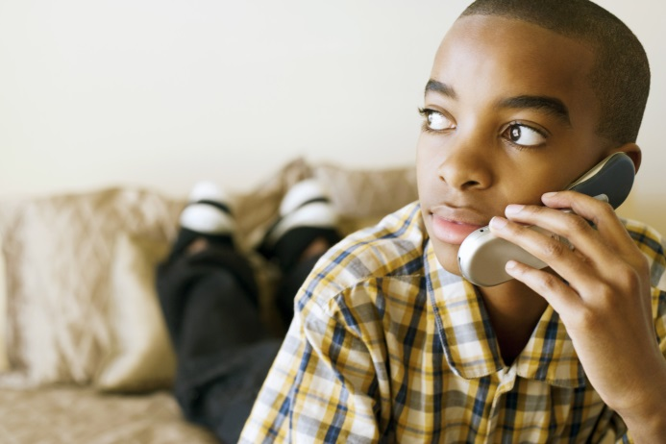
I can ask the person for a tour of the museum | [Insert photo of inside of museum]

About the museum

There are people who work at the museum who I can talk to | [Insert photo of museum staff]
The museum is usually a quiet place where people look at exhibits and art | [Insert photo of inside of museum]
Sometimes it might be noisy. If it is noisy I can talk to someone who works there | [Insert photo of museum staff]

The museum will have displays on…
[Delete or edit any that aren’t relevant.
Is there is anything potentially upsetting, add in: If I find this upsetting, I can leave this area]

Local history | [insert photo]
War  If I find this upsetting I can leave this area. | [insert photo]
Stuffed animals  If I find this upsetting I can leave this area. | [insert photo]
Old paintings | [insert photo]
Modern art | [insert photo]
[insert more] | [Insert photo]
[insert more] | [insert photo]

When I visit the museum

The museum is [free or costs £xxx to enter] | [insert photo or money or free sign]
I can walk around the museum at my own pace | [insert photo of museum room]
I must not touch anything that says do not touch. There will be a sign to say I can’t. | [insert photo of do not touch sign]
I can touch some things if there is a sign to say I can. | [insert photo of interactive sign]
The museum has a café I can go to  [delete if not applicable] | [Insert photo of café]
The museum will have a sensory room I can use  [delete if not applicable] | [Insert photo of sensory room]
When I have finished I will leave the museum | [insert photo of museum exit]

